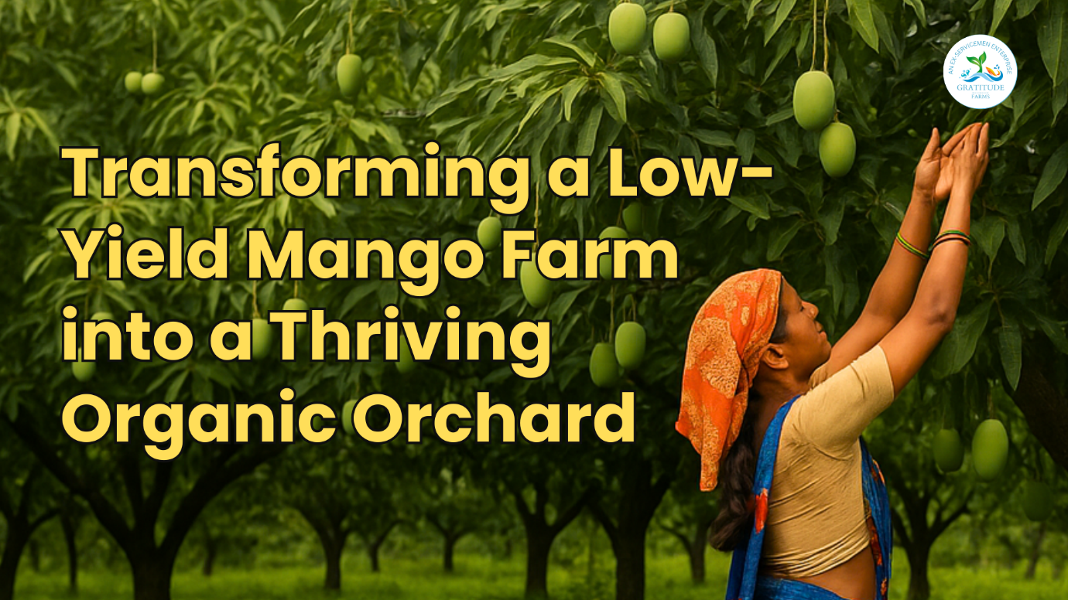

A Developing Case Study on the Power of Natural Farming and Vriksh Ayurveda
In the quiet landscapes of Marikal Village in Telangana, India, a remarkable transformation is unfolding—one that turned a struggling 125-acre mango farm into a thriving, high-yielding, organic orchard. This is not just a story of agricultural revival, but a testament to the power of Vriksh Ayurveda, Homa/Agnihotra, and natural farming practices in restoring life to the land.
Managed by Gratitude Farms, this (evolving) case study walks you through how ancient wisdom and modern strategy combined to breathe new life into mango cultivation.

The Background
The farm in question, with over 18,000 mango trees of varying ages (3 to 10 years) and four varieties of mangoes (Baiganpalli, Kesari, Dussehri and Royal Punasa), was grossly underperforming despite—and ironically because of —intensive chemical interventions. Heavy pesticide and fertilizer use failed to improve productivity. Instead, it degraded the soil, polluted the atmosphere, and harmed the local ecosystem.
When Gratitude Farms took over the Farm late last year, the vision was clear: restore the farmland using holistic, sustainable farming methods grounded in traditional Indian agricultural science. The goal was not just to improve yield but to regenerate the entire ecosystem.

Initial Observations and Challenges
A. Ultra-High-Density Plantation
Unlike the typical 40-50 trees per acre seen in conventional orchards, this farm had an ultra-high density of 160 to 180 trees per acre. While this could have meant higher productivity, the lack of proper canopy management led to densely packed trees fighting for sunlight and nutrients. There was no regular pruning or sunlight management, and this severely impacted tree and soil health.
Designing the Farmland is a foundational necessity for balancing the commercial benefits with Nature’s rules. This was conspicuous by its absence in this Farm.
B. Ecosystem Degradation
The farm showed clear signs of ecological collapse:
- Excessive use of chemicals in a bid to improve yields and manage pests without the basic eco-system improvement resulted in a complete loss of bio-diversity from the Farm (no birds, insects in the soil or butterflies and so on).

- The soil and foliage had high levels of chemical residue.

- Crucially, no pollinators such as honey bees were present, contributing to low fruit setting and poor yields.

- Knowledge Deficit lead to random actions from year-to-year

- Lack of knowledge of maintenance of Mango trees through their different growth stages.

- Poor canopy management (continual pruning is essential for high-density mango orchards) was not done, resulting in inadequate sunlight to the lower parts of the trees and to ground areas.

- Heavy pest infestation on most mango trees due to poor health and incorrect / inadequate nutrition and pest management.

- Managerial and Labour Issues: Inadequate managerial ability and poor labour management.
- Absence of Processes and Monitoring. No efforts on developing a process driven operations for the Farmland of this scale.

Result
Very low yields of mangoes over the last 4-5 years and heavy losses financially, making the Farmland financially unviable for the Farmland Owner.

Interventions Applied
A. Pruning and Cleaning
The first step was physical restoration:
- Over 12,000 trees were pruned systematically to allow sunlight to penetrate the orchard canopy.
- High-pressure water jets were used to clean the foliage and remove lingering chemical residues from years of pesticide use.
B. Soil Enrichment
Reviving the soil was essential:
- Natural farming preparations like Jeevamrutham and Panchkavyam were applied to the roots.
- These were enriched with critical micro and nano nutrients—for example, boron sourced from fermented Calotropis gigantea leaf juice—to address specific deficiencies.
C. Pest Control through Natural Farming Practices
Instead of chemical pesticides:
- Buttermilk sprays were used to deter pests while nourishing tree bark.
- A combination of Vriksh Ayurveda formulations and organic pest deterrents were applied during flowering and fruiting periods.
D. Vriksh Ayurveda Practices of Homa and Agnihotra
A unique aspect of the transformation was the integration of spiritual farming practices:
- Daily Homa/Agnihotra rituals were performed.
- These fire-based Vedic rituals purify the atmosphere, enhance nutrient absorption, and establish vibrational balance in the environment.
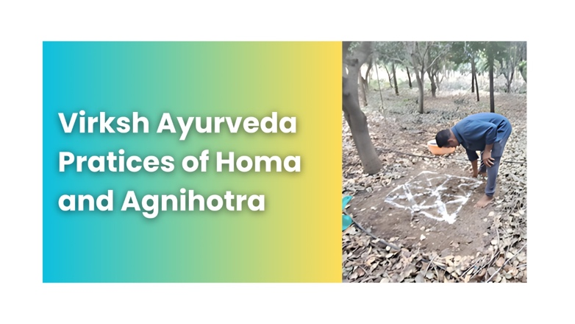
E. Ecosystem Revival
Within 2-3 months of implementing these practices:
- Birds, butterflies, and honey bees returned.
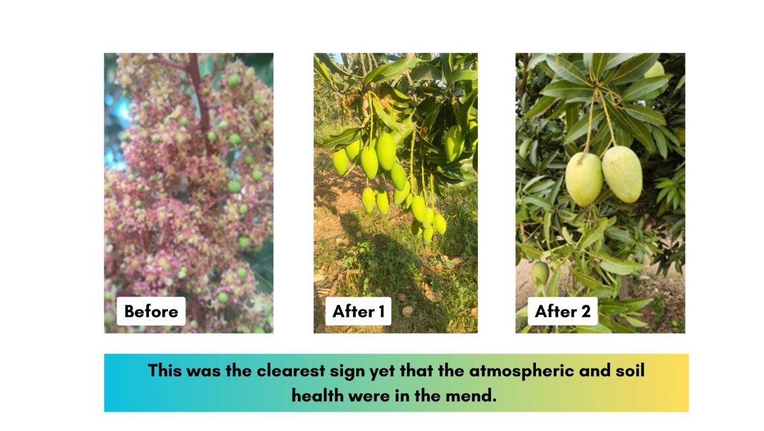
- Night-time life also began to stir again—frogs, fireflies, and other nocturnal beings reappeared.

Results: From Barren to Bountiful
The results have been very encouraging:
- Tree health visibly improved—lush, green foliage replaced the previously dull and disease-ridden leaves.
- Flowering became abundant and more consistent across the orchard.
- The fruit setting was much stronger, and the average weight of mangoes increased significantly.
Although exact numbers for the 2025 season are still being finalized, early indications suggest a dramatic jump in yield (to about 60 -80 tons this season as compared to merely 20 tons in each of the last two years).

Nutritional Improvement
The transformation is not just about quantity—it was about quality:
- The nutritional content of the mangoes improves significantly due to organic, pesticide-free farming.
- Taste, texture, and shelf life have all shown measurable enhancement.

The End of Chemical Dependency
This farm now stands as a living example of what happens when we reject chemical farming:
- No synthetic pesticides.
- No artificial fertilizers.
- No harm to soil microbiology, pollinators, or the broader environment.
In contrast, chemical farming had previously turned the land sterile. It had driven away pollinators, reduced biodiversity, and stripped the soil of life. Natural farming reversed all of that.

A Focus on Biodiversity and Atmospheric Balancing
Natural farming practices emphasize the importance of life—in the soil, on the trees, and in the air:
- The return of birds and bees wasn’t just a pleasant sight; it was essential for pollination and ecosystem services.
- The atmosphere became balanced through spiritual rituals and chemical-free air.
- Microbial activity in the soil returned, creating a nutrient-rich environment that supports robust plant growth.
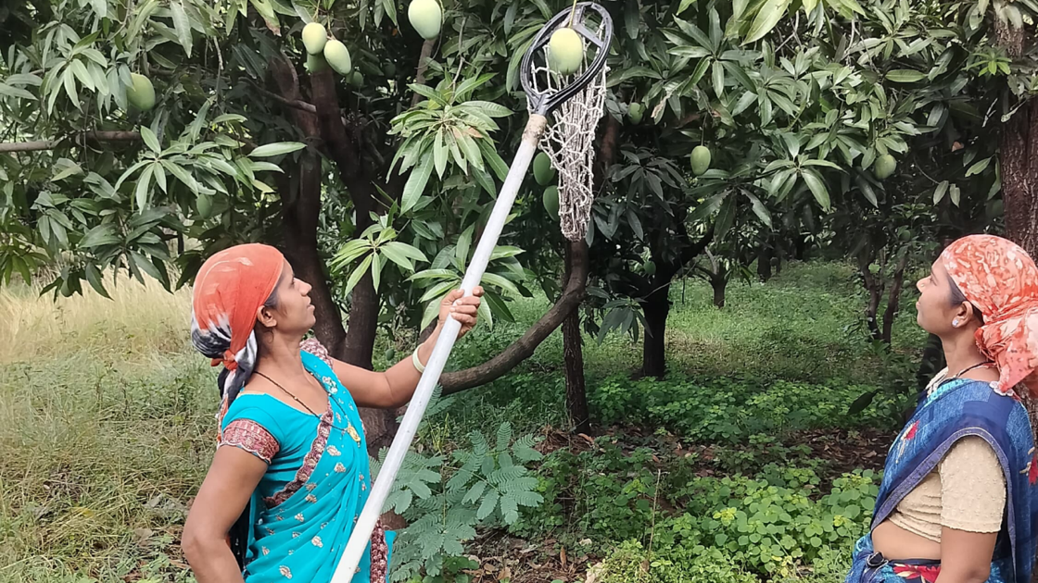

A Living Example
This 125-acre mango farm is now a living classroom for what sustainable agriculture can achieve:
- High yield without harming the land.
- Improved biodiversity and atmospheric health.
- Economic viability through reduced input costs and premium organic produce.
The transformation is not just agricultural—it was ecological and spiritual. This story from Marikal Village proves that with the right practices rooted in tradition and science, it is entirely possible to convert even the most degraded farmland into a thriving, self-sustaining ecosystem.
Gratitude Farms continues to manage and monitor this orchard, refining practices and documenting results. The lessons learned here are being shared widely, with hopes of inspiring similar transitions across India and beyond.

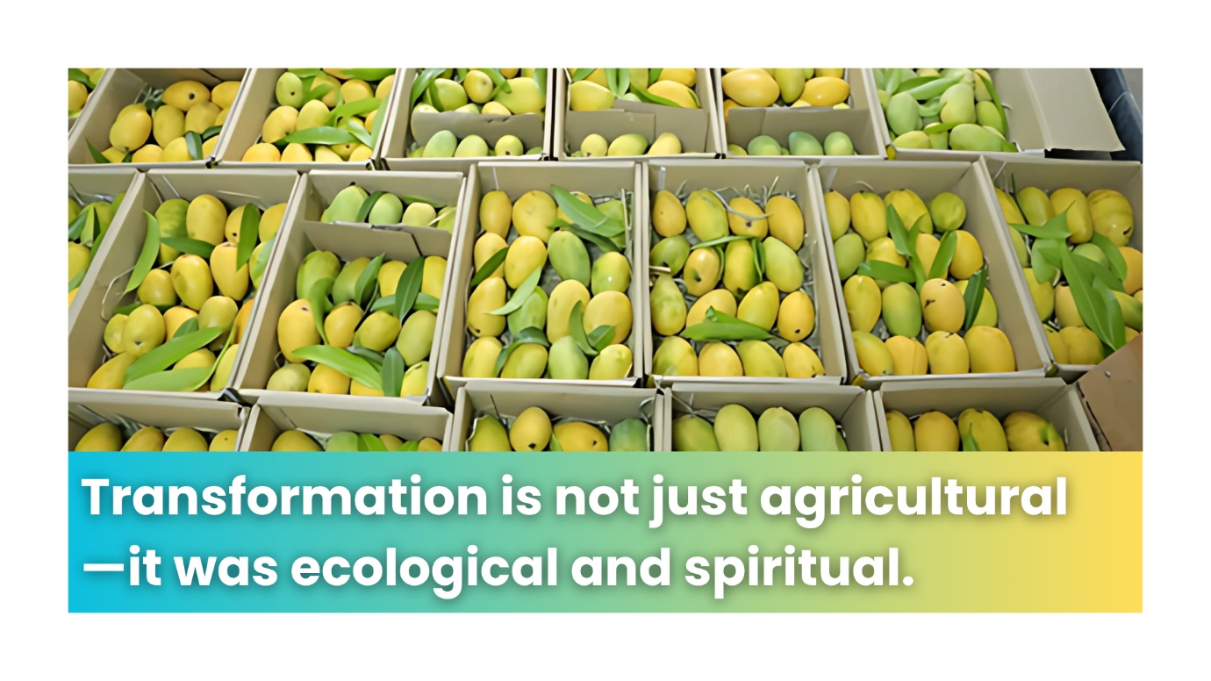

So, What is next?
We will continue to focus on soil fertility (improving microbial density, soil carbon and so on) and improving the overall biodiversity of the Farm.
After the monsoons (Oct to Feb), we will take up the series of actions for preparing for a yet better health and yield from the Farmland.
Multi-cropping to be Introduced.
We will introduce multi-cropping in open spaces with a range of complimentary plants and trees (mostly medicinal) that will add to the biodiversity as also generate additional revenue streams in the coming years.
Introduction to Agricultural Technologies:
- Drones and EV Robotic Tractors are going to be introduced for improving productivity and bringing in elements of Precision Farming.
- Data and Analytics. We are capturing operational and business data at minute levels. This will help us quantify benefits and improvements over time. And also enrich the Case Study with analysis of qualitative aspects of Natural Farming that we are implementing.
Value Additions
- Value additions like Aseptic pulping, dehydrated mango powder and so on are going to be introduced. Value additions like these require additional marketing efforts but give handsome revenue over time. Further, they prevent wastages significantly.
